**Analyzing Sentence Structure**

Earlier chapters focused on words: how to identify them, analyze their structure, assign them to lexical categories, and access their meanings. We have also seen how to identify patterns in word sequences or n-grams. However, these methods only scratch the surface of the complex constraints that govern sentences. We need a way to deal with the ambiguity that natural language is famous for. We also need to be able to cope with the fact that there are an unlimited number of possible sentences, and we can only write finite programs to analyze their structures and discover their meanings.

The goal of this chapter is to answer the following questions:

1. How can we use a formal grammar to describe the structure of an unlimited set of sentences?
2. How do we represent the structure of sentences using syntax trees?
3. How do parsers analyze a sentence and automatically build a syntax tree?

Along the way, we will cover the fundamentals of English syntax, and see that there are systematic aspects of meaning that are much easier to capture once we have identified the structure of sentences.

**1   Some Grammatical Dilemmas**

**1.1   Linguistic Data and Unlimited Possibilities**

Previous chapters have shown you how to process and analyse text corpora, and we have stressed the challenges for NLP in dealing with the vast amount of electronic language data that is growing daily. Let's consider this data more closely, and make the thought experiment that we have a gigantic corpus consisting of everything that has been either uttered or written in English over, say, the last 50 years. Would we be justified in calling this corpus "the language of modern English"? There are a number of reasons why we might answer No. Recall that in [3](https://www.nltk.org/book/ch03.html#chap-words), we asked you to search the web for instances of the pattern *the of*. Although it is easy to find examples on the web containing this word sequence, such as *New man at the of IMG* (http://www.telegraph.co.uk/sport/2387900/New-man-at-the-of-IMG.html), speakers of English will say that most such examples are errors, and therefore not part of English after all.

Accordingly, we can argue that the "modern English" is not equivalent to the very big set of word sequences in our imaginary corpus. Speakers of English can make judgements about these sequences, and will reject some of them as being ungrammatical.

Equally, it is easy to compose a new sentence and have speakers agree that it is perfectly good English. For example, sentences have an interesting property that they can be embedded inside larger sentences. Consider the following sentences:

|  |  |  |  |  |  |  |  |  |  |  |  |  |  |  |
| --- | --- | --- | --- | --- | --- | --- | --- | --- | --- | --- | --- | --- | --- | --- |
| (1) |  | |  |  |  | | --- | --- | --- | | a. |  | Usain Bolt broke the 100m record |  |  |  |  | | --- | --- | --- | | b. |  | The Jamaica Observer reported that Usain Bolt broke the 100m record |  |  |  |  | | --- | --- | --- | | c. |  | Andre said The Jamaica Observer reported that Usain Bolt broke the 100m record |  |  |  |  | | --- | --- | --- | | d. |  | I think Andre said the Jamaica Observer reported that Usain Bolt broke the 100m record | |

If we replaced whole sentences with the symbol S, we would see patterns like *Andre said* S and *I think* S. These are templates for taking a sentence and constructing a bigger sentence. There are other templates we can use, like S *but* S, and S *when* S. With a bit of ingenuity we can construct some really long sentences using these templates. Here's an impressive example from a Winnie the Pooh story by A.A. Milne, *In which Piglet is Entirely Surrounded by Water*:

[You can imagine Piglet's joy when at last the ship came in sight of him.] In after-years he liked to think that he had been in Very Great Danger during the Terrible Flood, but the only danger he had really been in was the last half-hour of his imprisonment, when Owl, who had just flown up, sat on a branch of his tree to comfort him, and told him a very long story about an aunt who had once laid a seagull's egg by mistake, and the story went on and on, rather like this sentence, until Piglet who was listening out of his window without much hope, went to sleep quietly and naturally, slipping slowly out of the window towards the water until he was only hanging on by his toes, at which moment, luckily, a sudden loud squawk from Owl, which was really part of the story, being what his aunt said, woke the Piglet up and just gave him time to jerk himself back into safety and say, "How interesting, and did she?" when — well, you can imagine his joy when at last he saw the good ship, Brain of Pooh (Captain, C. Robin; 1st Mate, P. Bear) coming over the sea to rescue him...

This long sentence actually has a simple structure that begins *S but S when S*. We can see from this example that language provides us with constructions which seem to allow us to extend sentences indefinitely. It is also striking that we can understand sentences of arbitrary length that we've never heard before: it's not hard to concoct an entirely novel sentence, one that has probably never been used before in the history of the language, yet all speakers of the language will understand it.

The purpose of a grammar is to give an explicit description of a language. But the way in which we think of a grammar is closely intertwined with what we consider to be a language. Is it a large but finite set of observed utterances and written texts? Is it something more abstract like the implicit knowledge that competent speakers have about grammatical sentences? Or is it some combination of the two? We won't take a stand on this issue, but instead will introduce the main approaches.

In this chapter, we will adopt the formal framework of "generative grammar", in which a "language" is considered to be nothing more than an enormous collection of all grammatical sentences, and a grammar is a formal notation that can be used for "generating" the members of this set. Grammars use recursive **productions** of the form S → S *and* S, as we will explore in [3](https://www.nltk.org/book/ch08.html" \l "sec-context-free-grammar). In [10.](https://www.nltk.org/book/ch10.html#chap-semantics) we will extend this, to automatically build up the meaning of a sentence out of the meanings of its parts.

**1.2   Ubiquitous Ambiguity**

A well-known example of ambiguity is shown in [(2)](https://www.nltk.org/book/ch08.html#ex-marx-elephant), from the Groucho Marx movie, *Animal Crackers* (1930):

|  |  |  |
| --- | --- | --- |
| (2) |  | While hunting in Africa, I shot an elephant in my pajamas. How he got into my pajamas, I don't know. |

Let's take a closer look at the ambiguity in the phrase: *I shot an elephant in my pajamas*. First we need to define a simple grammar:

|  |  |  |
| --- | --- | --- |
| |  |  | | --- | --- | |  | **>>> groucho\_grammar = nltk.CFG.fromstring("""**  **... S -> NP VP**  **... PP -> P NP**  **... NP -> Det N | Det N PP | 'I'**  **... VP -> V NP | VP PP**  **... Det -> 'an' | 'my'**  **... N -> 'elephant' | 'pajamas'**  **... V -> 'shot'**  **... P -> 'in'**  **... """)** | |

This grammar permits the sentence to be analyzed in two ways, depending on whether the prepositional phrase *in my pajamas* describes the elephant or the shooting event.

|  |  |  |
| --- | --- | --- |
| |  |  | | --- | --- | |  | **>>> sent = ['I', 'shot', 'an', 'elephant', 'in', 'my', 'pajamas']**  **>>> parser = nltk.ChartParser(groucho\_grammar)**  **>>> for tree in parser.parse(sent):**  **... print(tree)**  **...**  **(S**  **(NP I)**  **(VP**  **(VP (V shot) (NP (Det an) (N elephant)))**  **(PP (P in) (NP (Det my) (N pajamas)))))**  **(S**  **(NP I)**  **(VP**  **(V shot)**  **(NP (Det an) (N elephant) (PP (P in) (NP (Det my) (N pajamas))))))** | |

The program produces two bracketed structures, which we can depict as trees, as shown in [(3b)](https://www.nltk.org/book/ch08.html#ex-elephant):

|  |  |  |  |  |  |  |  |  |
| --- | --- | --- | --- | --- | --- | --- | --- | --- |
| (3) |  | |  |  |  | | --- | --- | --- | | a. |  | tree_images/ch08-tree-1.png |  |  |  |  | | --- | --- | --- | | b. |  | tree_images/ch08-tree-2.png | |

Notice that there's no ambiguity concerning the meaning of any of the words; e.g. the word *shot* doesn't refer to the act of using a gun in the first sentence, and using a camera in the second sentence.

**Note**

**Your Turn:** Consider the following sentences and see if you can think of two quite different interpretations: *Fighting animals could be dangerous.* *Visiting relatives can be tiresome.* Is ambiguity of the individual words to blame? If not, what is the cause of the ambiguity?

This chapter presents grammars and parsing, as the formal and computational methods for investigating and modeling the linguistic phenomena we have been discussing. As we shall see, patterns of well-formedness and ill-formedness in a sequence of words can be understood with respect to the phrase structure and dependencies. We can develop formal models of these structures using grammars and parsers. As before, a key motivation is natural language *understanding*. How much more of the meaning of a text can we access when we can reliably recognize the linguistic structures it contains? Having read in a text, can a program "understand" it enough to be able to answer simple questions about "what happened" or "who did what to whom"? Also as before, we will develop simple programs to process annotated corpora and perform useful tasks.

**2   What's the Use of Syntax?**

**2.1   Beyond n-grams**

We gave an example in [2.](https://www.nltk.org/book/ch02.html#chap-corpora) of how to use the frequency information in bigrams to generate text that seems perfectly acceptable for small sequences of words but rapidly degenerates into nonsense. Here's another pair of examples that we created by computing the bigrams over the text of a childrens' story, *The Adventures of Buster Brown* (http://www.gutenberg.org/files/22816/22816.txt):

|  |  |  |  |  |  |  |  |  |
| --- | --- | --- | --- | --- | --- | --- | --- | --- |
| (4) |  | |  |  |  | | --- | --- | --- | | a. |  | He roared with me the pail slip down his back |  |  |  |  | | --- | --- | --- | | b. |  | The worst part and clumsy looking for whoever heard light | |

You intuitively know that these sequences are "word-salad", but you probably find it hard to pin down what's wrong with them. One benefit of studying grammar is that it provides a conceptual framework and vocabulary for spelling out these intuitions. Let's take a closer look at the sequence *the worst part and clumsy looking*. This looks like a **coordinate structure**, where two phrases are joined by a coordinating conjunction such as *and*, *but* or *or*. Here's an informal (and simplified) statement of how coordination works syntactically:

Coordinate Structure:

If *v*1 and *v*2 are both phrases of grammatical category *X*, then *v*1 *and* *v*2 is also a phrase of category *X*.

Here are a couple of examples. In the first, two NPs (noun phrases) have been conjoined to make an NP, while in the second, two APs (adjective phrases) have been conjoined to make an AP.

|  |  |  |  |  |  |  |  |  |
| --- | --- | --- | --- | --- | --- | --- | --- | --- |
| (5) |  | |  |  |  | | --- | --- | --- | | a. |  | The book's ending was (NP *the worst part and the best part*) for me. |  |  |  |  | | --- | --- | --- | | b. |  | On land they are (AP *slow and clumsy looking*). | |

What we *can't* do is conjoin an NP and an AP, which is why *the worst part and clumsy looking* is ungrammatical. Before we can formalize these ideas, we need to understand the concept of **constituent structure**.

Constituent structure is based on the observation that words combine with other words to form units. The evidence that a sequence of words forms such a unit is given by substitutability — that is, a sequence of words in a well-formed sentence can be replaced by a shorter sequence without rendering the sentence ill-formed. To clarify this idea, consider the following sentence:

|  |  |  |
| --- | --- | --- |
| (6) |  | The little bear saw the fine fat trout in the brook. |

The fact that we can substitute *He* for *The little bear* indicates that the latter sequence is a unit. By contrast, we cannot replace *little bear saw* in the same way.

|  |  |  |  |  |  |  |  |  |
| --- | --- | --- | --- | --- | --- | --- | --- | --- |
| (7) |  | |  |  |  | | --- | --- | --- | | a. |  | He saw the fine fat trout in the brook. |  |  |  |  | | --- | --- | --- | | b. |  | \*The he the fine fat trout in the brook. | |

In [2.1](https://www.nltk.org/book/ch08.html" \l "fig-ic-diagram), we systematically substitute longer sequences by shorter ones in a way which preserves grammaticality. Each sequence that forms a unit can in fact be replaced by a single word, and we end up with just two elements.

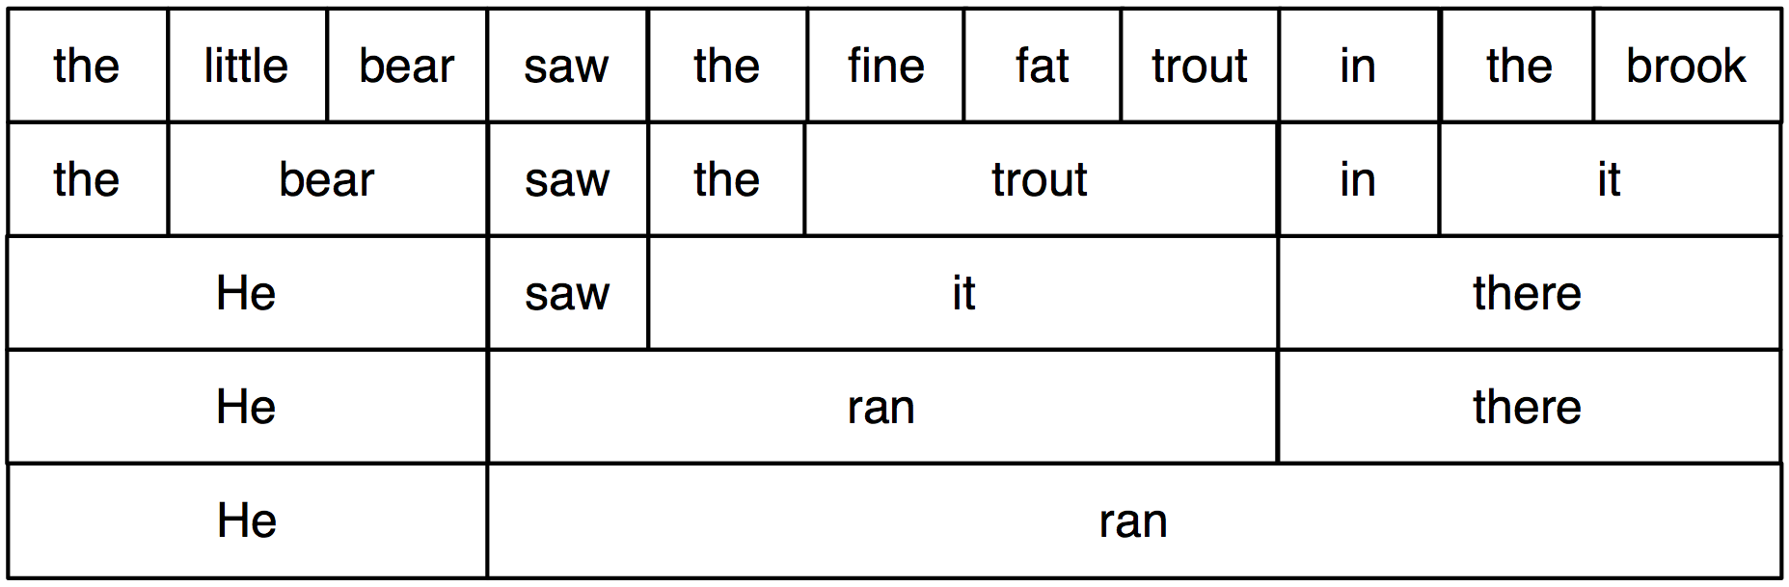

***Figure 2.1****: Substitution of Word Sequences: working from the top row, we can replace particular sequences of words (e.g. the brook) with individual words (e.g. it); repeating this process we arrive at a grammatical two-word sentence.*

In [2.2](https://www.nltk.org/book/ch08.html#fig-ic-diagram-labeled), we have added grammatical category labels to the words we saw in the earlier figure. The labels NP, VP, and PP stand for **noun phrase**, **verb phrase** and **prepositional phrase** respectively.

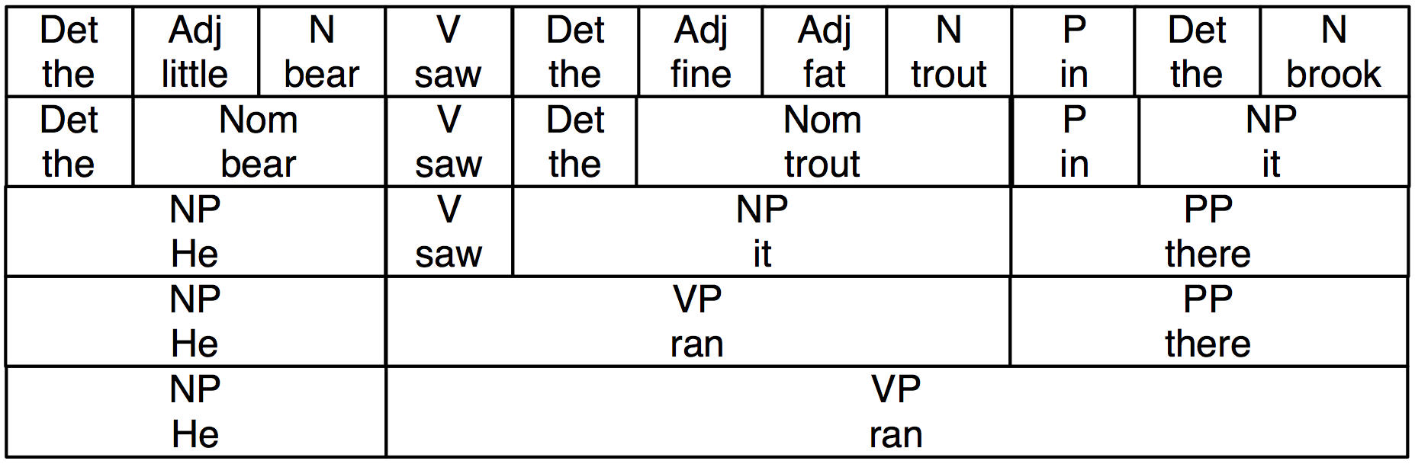

***Figure 2.2****: Substitution of Word Sequences Plus Grammatical Categories: This diagram reproduces [2.1](https://www.nltk.org/book/ch08.html" \l "fig-ic-diagram) along with grammatical categories corresponding to noun phrases (NP), verb phrases (VP), prepositional phrases (PP), and nominals (Nom).*

If we now strip out the words apart from the topmost row, add an S node, and flip the figure over, we end up with a standard phrase structure tree, shown in [(8)](https://www.nltk.org/book/ch08.html#ex-phrase-structure-tree). Each node in this tree (including the words) is called a **constituent**. The **immediate constituents** of S are NP and VP.

|  |  |  |
| --- | --- | --- |
| (8) |  | tree_images/ch08-tree-3.png |

As we will see in the next section, a grammar specifies how the sentence can be subdivided into its immediate constituents, and how these can be further subdivided until we reach the level of individual words.

**Note**

As we saw in [1](https://www.nltk.org/book/ch08.html" \l "sec-dilemmas), sentences can have arbitrary length. Consequently, phrase structure trees can have arbitrary *depth*. The cascaded chunk parsers we saw in [4](https://www.nltk.org/book/ch07.html#sec-recursion-in-linguistic-structure) can only produce structures of bounded depth, so chunking methods aren't applicable here.

**3   Context Free Grammar**

**3.1   A Simple Grammar**

Let's start off by looking at a simple context-free grammar. By convention, the left-hand-side of the first production is the **start-symbol** of the grammar, typically S, and all well-formed trees must have this symbol as their root label. In NLTK, context-free grammars are defined in the nltk.grammar module. In [3.1](https://www.nltk.org/book/ch08.html" \l "code-cfg1) we define a grammar and show how to parse a simple sentence admitted by the grammar.

|  |  |  |
| --- | --- | --- |
| |  |  | | --- | --- | |  | **grammar1 = nltk.CFG.fromstring("""**  **S -> NP VP**  **VP -> V NP | V NP PP**  **PP -> P NP**  **V -> "saw" | "ate" | "walked"**  **NP -> "John" | "Mary" | "Bob" | Det N | Det N PP**  **Det -> "a" | "an" | "the" | "my"**  **N -> "man" | "dog" | "cat" | "telescope" | "park"**  **P -> "in" | "on" | "by" | "with"**  **""")** | |
| |  |  | | --- | --- | |  | **>>> sent = "Mary saw Bob".split()**  **>>> rd\_parser = nltk.RecursiveDescentParser(grammar1)**  **>>> for tree in rd\_parser.parse(sent):**  **... print(tree)**  **(S (NP Mary) (VP (V saw) (NP Bob)))** | |
| [**Example 3.1 (code\_cfg1.py)**](https://www.nltk.org/book/pylisting/code_cfg1.py): **Figure 3.1**: A Simple Context-Free Grammar |

The grammar in [3.1](https://www.nltk.org/book/ch08.html#code-cfg1) contains productions involving various syntactic categories, as laid out in [3.1](https://www.nltk.org/book/ch08.html#tab-syncat).

***Table 3.1****:*

Syntactic Categories

| **Symbol** | **Meaning** | **Example** |
| --- | --- | --- |
| S | sentence | *the man walked* |
| NP | noun phrase | *a dog* |
| VP | verb phrase | *saw a park* |
| PP | prepositional phrase | *with a telescope* |
| Det | determiner | *the* |
| N | noun | *dog* |
| V | verb | *walked* |
| P | preposition | *in* |

A production like VP -> V NP | V NP PP has a disjunction on the righthand side, shown by the | and is an abbreviation for the two productions VP -> V NP and VP -> V NP PP.

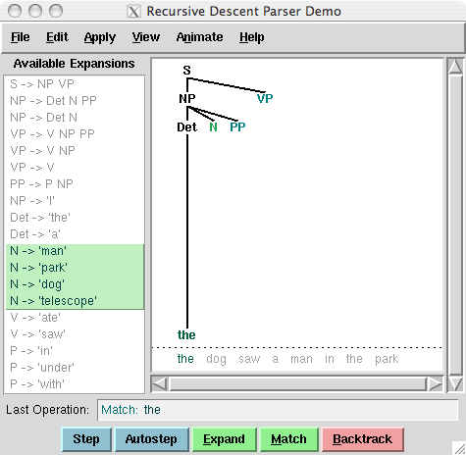

***Figure 3.2****: Recursive Descent Parser Demo: This tool allows you to watch the operation of a recursive descent parser as it grows the parse tree and matches it against the input words.*

**Note**

**Your Turn:** Try developing a simple grammar of your own, using the recursive descent parser application, nltk.app.rdparser(), shown in [3.2](https://www.nltk.org/book/ch08.html#fig-parse-rdparsewindow). It comes already loaded with a sample grammar, but you can edit this as you please (using the Edit menu). Change the grammar, and the sentence to be parsed, and run the parser using the *autostep* button.

If we parse the sentence *The dog saw a man in the park* using the grammar shown in [3.1](https://www.nltk.org/book/ch08.html#code-cfg1), we end up with two trees, similar to those we saw for [(3b)](https://www.nltk.org/book/ch08.html#ex-elephant):

|  |  |  |  |  |  |  |  |  |
| --- | --- | --- | --- | --- | --- | --- | --- | --- |
| (9) |  | |  |  |  | | --- | --- | --- | | a. |  | tree_images/ch08-tree-4.png |  |  |  |  | | --- | --- | --- | | b. |  | tree_images/ch08-tree-5.png | |

Since our grammar licenses two trees for this sentence, the sentence is said to be **structurally ambiguous**. The ambiguity in question is called a prepositional phrase attachment ambiguity, as we saw earlier in this chapter. As you may recall, it is an ambiguity about attachment since the PP *in the park* needs to be attached to one of two places in the tree: either as a child of VP or else as a child of NP. When the PP is attached to VP, the intended interpretation is that the seeing event happened in the park. However, if the PP is attached to NP, then it was the man who was in the park, and the agent of the seeing (the dog) might have been sitting on the balcony of an apartment overlooking the park.

**3.2   Writing Your Own Grammars**

If you are interested in experimenting with writing CFGs, you will find it helpful to create and edit your grammar in a text file, say mygrammar.cfg. You can then load it into NLTK and parse with it as follows:

|  |  |  |
| --- | --- | --- |
| |  |  | | --- | --- | |  | **>>> grammar1 = nltk.data.load('file:mygrammar.cfg')**  **>>> sent = "Mary saw Bob".split()**  **>>> rd\_parser = nltk.RecursiveDescentParser(grammar1)**  **>>> for tree in rd\_parser.parse(sent):**  **... print(tree)** | |

Make sure that you put a .cfg suffix on the filename, and that there are no spaces in the string 'file:mygrammar.cfg'. If the command print(tree) produces no output, this is probably because your sentence sent is not admitted by your grammar. In this case, call the parser with tracing set to be on: rd\_parser =

nltk.RecursiveDescentParser(grammar1, trace=2). You can also check what productions are currently in the grammar with the command for p

in grammar1.productions(): print(p).

When you write CFGs for parsing in NLTK, you cannot combine grammatical categories with lexical items on the righthand side of the same production. Thus, a production such as PP -> 'of' NP is disallowed. In addition, you are not permitted to place multi-word lexical items on the righthand side of a production. So rather than writing NP -> 'New

York', you have to resort to something like NP -> 'New\_York' instead.

**3.3   Recursion in Syntactic Structure**

A grammar is said to be **recursive** if a category occurring on the left hand side of a production also appears on the righthand side of a production, as illustrated in [3.3](https://www.nltk.org/book/ch08.html" \l "code-cfg2). The production Nom -> Adj Nom (where Nom is the category of nominals) involves direct recursion on the category Nom, whereas indirect recursion on S arises from the combination of two productions, namely S -> NP VP and VP -> V S.

|  |  |  |
| --- | --- | --- |
| |  |  | | --- | --- | |  | **grammar2 = nltk.CFG.fromstring("""**  **S -> NP VP**  **NP -> Det Nom | PropN**  **Nom -> Adj Nom | N**  **VP -> V Adj | V NP | V S | V NP PP**  **PP -> P NP**  **PropN -> 'Buster' | 'Chatterer' | 'Joe'**  **Det -> 'the' | 'a'**  **N -> 'bear' | 'squirrel' | 'tree' | 'fish' | 'log'**  **Adj -> 'angry' | 'frightened' | 'little' | 'tall'**  **V -> 'chased' | 'saw' | 'said' | 'thought' | 'was' | 'put'**  **P -> 'on'**  **""")** | |
| [**Example 3.3 (code\_cfg2.py)**](https://www.nltk.org/book/pylisting/code_cfg2.py): **Figure 3.3**: A Recursive Context-Free Grammar |

To see how recursion arises from this grammar, consider the following trees. [(10a)](https://www.nltk.org/book/ch08.html#ex-recnominals) involves nested nominal phrases, while [(10b)](https://www.nltk.org/book/ch08.html#ex-recsentences) contains nested sentences.

|  |  |  |  |  |  |  |  |  |
| --- | --- | --- | --- | --- | --- | --- | --- | --- |
| (10) |  | |  |  |  | | --- | --- | --- | | a. |  | tree_images/ch08-tree-6.png |  |  |  |  | | --- | --- | --- | | b. |  | tree_images/ch08-tree-7.png | |

We've only illustrated two levels of recursion here, but there's no upper limit on the depth. You can experiment with parsing sentences that involve more deeply nested structures. Beware that the RecursiveDescentParser is unable to handle **left-recursive** productions of the form X -> X Y; we will return to this in [4](https://www.nltk.org/book/ch08.html" \l "sec-parsing).

**4   Parsing With Context Free Grammar**

A **parser** processes input sentences according to the productions of a grammar, and builds one or more constituent structures that conform to the grammar. A grammar is a declarative specification of well-formedness — it is actually just a string, not a program. A parser is a procedural interpretation of the grammar. It searches through the space of trees licensed by a grammar to find one that has the required sentence along its fringe.

A parser permits a grammar to be evaluated against a collection of test sentences, helping linguists to discover mistakes in their grammatical analysis. A parser can serve as a model of psycholinguistic processing, helping to explain the difficulties that humans have with processing certain syntactic constructions. Many natural language applications involve parsing at some point; for example, we would expect the natural language questions submitted to a question-answering system to undergo parsing as an initial step.

In this section we see two simple parsing algorithms, a top-down method called recursive descent parsing, and a bottom-up method called shift-reduce parsing. We also see some more sophisticated algorithms, a top-down method with bottom-up filtering called left-corner parsing, and a dynamic programming technique called chart parsing.

**4.1   Recursive Descent Parsing**

The simplest kind of parser interprets a grammar as a specification of how to break a high-level goal into several lower-level subgoals. The top-level goal is to find an S. The S → NP VP production permits the parser to replace this goal with two subgoals: find an NP, then find a VP. Each of these subgoals can be replaced in turn by sub-sub-goals, using productions that have NP and VP on their left-hand side. Eventually, this expansion process leads to subgoals such as: find the word *telescope*. Such subgoals can be directly compared against the input sequence, and succeed if the next word is matched. If there is no match the parser must back up and try a different alternative.

The recursive descent parser builds a parse tree during the above process. With the initial goal (find an S), the S root node is created. As the above process recursively expands its goals using the productions of the grammar, the parse tree is extended downwards (hence the name *recursive descent*). We can see this in action using the graphical demonstration nltk.app.rdparser(). Six stages of the execution of this parser are shown in [4.1](https://www.nltk.org/book/ch08.html" \l "fig-rdparser1-6).

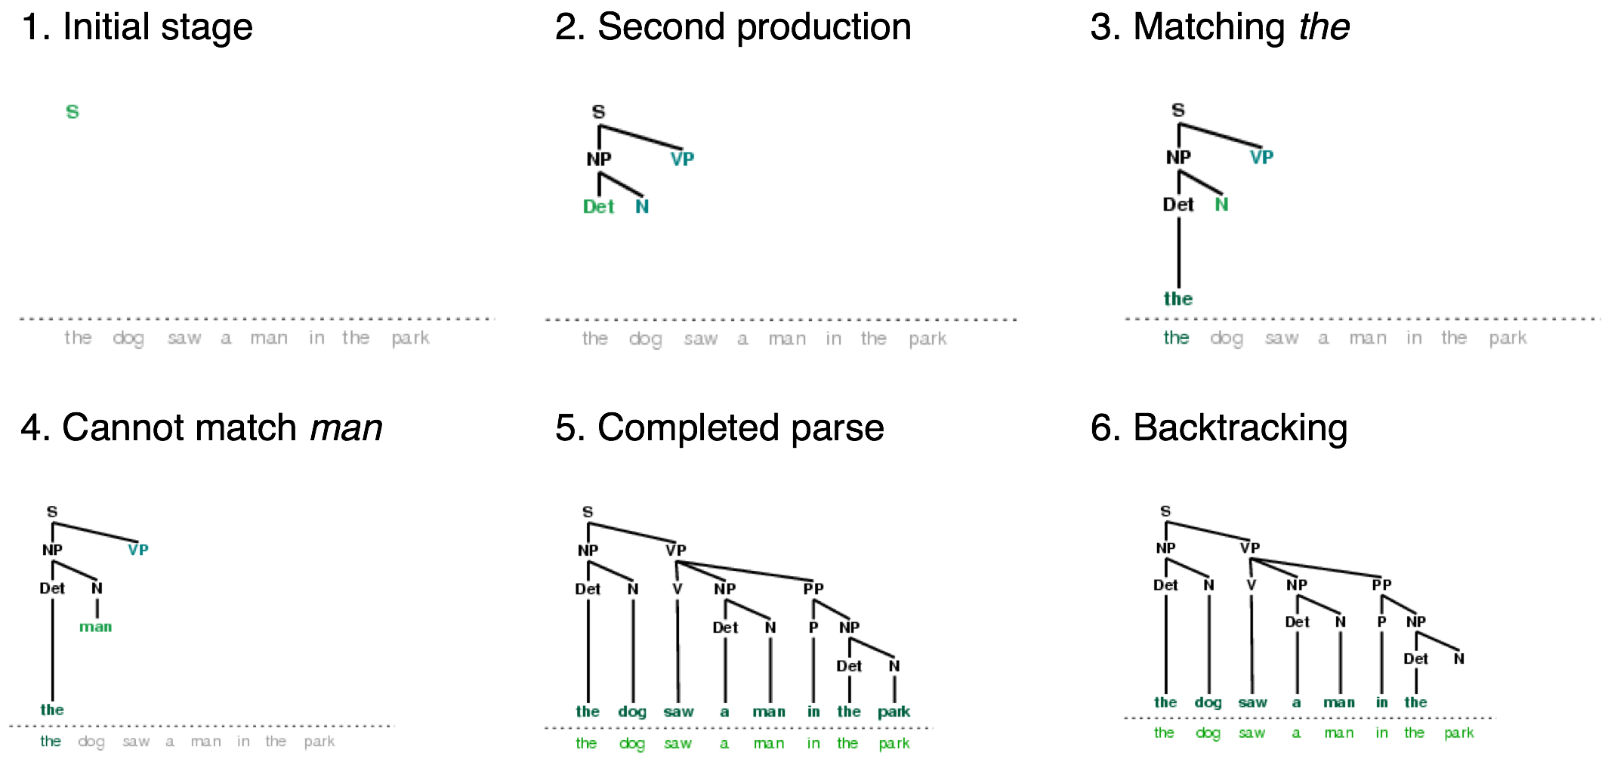

***Figure 4.1****: Six Stages of a Recursive Descent Parser: the parser begins with a tree consisting of the node S; at each stage it consults the grammar to find a production that can be used to enlarge the tree; when a lexical production is encountered, its word is compared against the input; after a complete parse has been found, the parser backtracks to look for more parses.*

During this process, the parser is often forced to choose between several possible productions. For example, in going from step 3 to step 4, it tries to find productions with N on the left-hand side. The first of these is N → *man*. When this does not work it backtracks, and tries other N productions in order, until it gets to N → *dog*, which matches the next word in the input sentence. Much later, as shown in step 5, it finds a complete parse. This is a tree that covers the entire sentence, without any dangling edges. Once a parse has been found, we can get the parser to look for additional parses. Again it will backtrack and explore other choices of production in case any of them result in a parse.

NLTK provides a recursive descent parser:

|  |  |  |
| --- | --- | --- |
| |  |  | | --- | --- | |  | **>>> rd\_parser = nltk.RecursiveDescentParser(grammar1)**  **>>> sent = 'Mary saw a dog'.split()**  **>>> for tree in rd\_parser.parse(sent):**  **... print(tree)**  **(S (NP Mary) (VP (V saw) (NP (Det a) (N dog))))** | |

**Note**

RecursiveDescentParser() takes an optional parameter trace. If trace is greater than zero, then the parser will report the steps that it takes as it parses a text.

Recursive descent parsing has three key shortcomings. First, left-recursive productions like NP -> NP PP send it into an infinite loop. Second, the parser wastes a lot of time considering words and structures that do not correspond to the input sentence. Third, the backtracking process may discard parsed constituents that will need to be rebuilt again later. For example, backtracking over VP -> V NP will discard the subtree created for the NP. If the parser then proceeds with VP -> V NP PP, then the NP subtree must be created all over again.

Recursive descent parsing is a kind of **top-down parsing**. Top-down parsers use a grammar to *predict* what the input will be, before inspecting the input! However, since the input is available to the parser all along, it would be more sensible to consider the input sentence from the very beginning. This approach is called **bottom-up parsing**, and we will see an example in the next section.

**4.2   Shift-Reduce Parsing**

A simple kind of bottom-up parser is the **shift-reduce parser**. In common with all bottom-up parsers, a shift-reduce parser tries to find sequences of words and phrases that correspond to the *right hand* side of a grammar production, and replace them with the left-hand side, until the whole sentence is reduced to an S.

The shift-reduce parser repeatedly pushes the next input word onto a stack ([4.1](https://www.nltk.org/book/ch04.html" \l "sec-back-to-the-basics)); this is the **shift** operation. If the top *n* items on the stack match the *n* items on the right hand side of some production, then they are all popped off the stack, and the item on the left-hand side of the production is pushed on the stack. This replacement of the top *n* items with a single item is the **reduce** operation. This operation may only be applied to the top of the stack; reducing items lower in the stack must be done before later items are pushed onto the stack. The parser finishes when all the input is consumed and there is only one item remaining on the stack, a parse tree with an S node as its root. The shift-reduce parser builds a parse tree during the above process. Each time it pops *n* items off the stack it combines them into a partial parse tree, and pushes this back on the stack. We can see the shift-reduce parsing algorithm in action using the graphical demonstration nltk.app.srparser(). Six stages of the execution of this parser are shown in [4.2](https://www.nltk.org/book/ch08.html" \l "fig-srparser1-6).

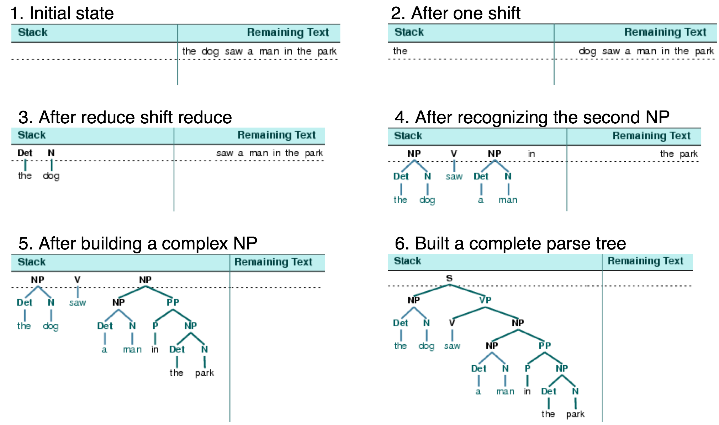

***Figure 4.2****: Six Stages of a Shift-Reduce Parser: the parser begins by shifting the first input word onto its stack; once the top items on the stack match the right hand side of a grammar production, they can be replaced with the left hand side of that production; the parser succeeds once all input is consumed and one S item remains on the stack.*

NLTK provides ShiftReduceParser(), a simple implementation of a shift-reduce parser. This parser does not implement any backtracking, so it is not guaranteed to find a parse for a text, even if one exists. Furthermore, it will only find at most one parse, even if more parses exist. We can provide an optional trace parameter that controls how verbosely the parser reports the steps that it takes as it parses a text:

|  |  |  |
| --- | --- | --- |
| |  |  | | --- | --- | |  | **>>> sr\_parser = nltk.ShiftReduceParser(grammar1)**  **>>> sent = 'Mary saw a dog'.split()**  **>>> for tree in sr\_parser.parse(sent):**  **... print(tree)**  **(S (NP Mary) (VP (V saw) (NP (Det a) (N dog))))** | |

**Note**

**Your Turn:** Run the above parser in tracing mode to see the sequence of shift and reduce operations, using sr\_parse = nltk.ShiftReduceParser(grammar1, trace=2)

A shift-reduce parser can reach a dead end and fail to find any parse, even if the input sentence is well-formed according to the grammar. When this happens, no input remains, and the stack contains items which cannot be reduced to an S. The problem arises because there are choices made earlier that cannot be undone by the parser (although users of the graphical demonstration can undo their choices). There are two kinds of choices to be made by the parser: (a) which reduction to do when more than one is possible (b) whether to shift or reduce when either action is possible.

A shift-reduce parser may be extended to implement policies for resolving such conflicts. For example, it may address shift-reduce conflicts by shifting only when no reductions are possible, and it may address reduce-reduce conflicts by favoring the reduction operation that removes the most items from the stack. (A generalization of shift-reduce parser, a "lookahead LR parser", is commonly used in programming language compilers.)

The advantage of shift-reduce parsers over recursive descent parsers is that they only build structure that corresponds to the words in the input. Furthermore, they only build each sub-structure once, e.g. NP(Det(the), N(man)) is only built and pushed onto the stack a single time, regardless of whether it will later be used by the VP -> V NP PP reduction or the NP -> NP PP reduction.

**4.3   The Left-Corner Parser**

One of the problems with the recursive descent parser is that it goes into an infinite loop when it encounters a left-recursive production. This is because it applies the grammar productions blindly, without considering the actual input sentence. A left-corner parser is a hybrid between the bottom-up and top-down approaches we have seen.

Grammar grammar1 allows us to produce the following parse of *John saw Mary*:

|  |  |  |
| --- | --- | --- |
| (11) |  | tree_images/ch08-tree-8.png |

Recall that the grammar (defined in [3.3](https://www.nltk.org/book/ch08.html#code-cfg2)) has the following productions for expanding NP:

|  |  |  |  |  |  |  |  |  |  |  |  |
| --- | --- | --- | --- | --- | --- | --- | --- | --- | --- | --- | --- |
| (12) |  | |  |  |  | | --- | --- | --- | | a. |  | NP -> Det N |  |  |  |  | | --- | --- | --- | | b. |  | NP -> Det N PP |  |  |  |  | | --- | --- | --- | | c. |  | NP -> "John" | "Mary" | "Bob" | |

Suppose we ask you to first look at tree [(11)](https://www.nltk.org/book/ch08.html#ex-jmtree), and then decide which of the NP productions you'd want a recursive descent parser to apply first — obviously, [(12c)](https://www.nltk.org/book/ch08.html#ex-r3) is the right choice! How do you know that it would be pointless to apply [(12a)](https://www.nltk.org/book/ch08.html#ex-r1) or [(12b)](https://www.nltk.org/book/ch08.html#ex-r2) instead? Because neither of these productions will derive a sequence whose first word is *John*. That is, we can easily tell that in a successful parse of *John saw Mary*, the parser has to expand NP in such a way that NP derives the sequence *John* α. More generally, we say that a category *B* is a **left-corner** of a tree rooted in *A* if *A* ⇒\* *B* α.

|  |  |  |
| --- | --- | --- |
| (13) |  | tree_images/ch08-tree-9.png |

A **left-corner parser** is a top-down parser with bottom-up filtering. Unlike an ordinary recursive descent parser, it does not get trapped in left recursive productions. Before starting its work, a left-corner parser preprocesses the context-free grammar to build a table where each row contains two cells, the first holding a non-terminal, and the second holding the collection of possible left corners of that non-terminal. [4.1](https://www.nltk.org/book/ch08.html" \l "tab-lc) illustrates this for the grammar from grammar2.

***Table 4.1****:*

Left-Corners in grammar2

| **Category** | **Left-Corners (pre-terminals)** |
| --- | --- |
| S | NP |
| NP | Det, PropN |
| VP | V |
| PP | P |

Each time a production is considered by the parser, it checks that the next input word is compatible with at least one of the pre-terminal categories in the left-corner table.

**4.4   Well-Formed Substring Tables**

The simple parsers discussed above suffer from limitations in both completeness and efficiency. In order to remedy these, we will apply the algorithm design technique of dynamic programming to the parsing problem. As we saw in [4.7](https://www.nltk.org/book/ch04.html" \l "sec-algorithm-design), dynamic programming stores intermediate results and re-uses them when appropriate, achieving significant efficiency gains. This technique can be applied to syntactic parsing, allowing us to store partial solutions to the parsing task and then look them up as necessary in order to efficiently arrive at a complete solution. This approach to parsing is known as **chart parsing**. We introduce the main idea in this section; see the online materials available for this chapter for more implementation details.

Dynamic programming allows us to build the PP *in my pajamas* just once. The first time we build it we save it in a table, then we look it up when we need to use it as a subconstituent of either the object NP or the higher VP. This table is known as a **well-formed substring table**, or WFST for short. (The term "substring" refers to a contiguous sequence of words within a sentence.) We will show how to construct the WFST bottom-up so as to systematically record what syntactic constituents have been found.

Let's set our input to be the sentence in [(2)](https://www.nltk.org/book/ch08.html" \l "ex-marx-elephant). The numerically specified spans of the WFST are reminiscent of Python's slice notation ([3.2](https://www.nltk.org/book/ch03.html#sec-strings)). Another way to think about the data structure is shown in [4.3](https://www.nltk.org/book/ch08.html#fig-chart-positions1), a data structure known as a **chart**.

../images/chart_positions1.png

***Figure 4.3****: The Chart Data Structure: words are the edge labels of a linear graph structure.*

In a WFST, we record the position of the words by filling in cells in a triangular matrix: the vertical axis will denote the start position of a substring, while the horizontal axis will denote the end position (thus *shot* will appear in the cell with coordinates (1, 2)). To simplify this presentation, we will assume each word has a unique lexical category, and we will store this (not the word) in the matrix. So cell (1, 2) will contain the entry V. More generally, if our input string is *a*0*a*1 ... *a*n, and our grammar contains a production of the form *A* → *a*i, then we add *A* to the cell (*i*, [`](https://www.nltk.org/book/ch08.html" \l "id1)i`+1).

**System Message: WARNING/2 (ch08.rst2, line 900);**[***backlink***](https://www.nltk.org/book/ch08.html#id2)

Inline interpreted text or phrase reference start-string without end-string.

So, for every word in text, we can look up in our grammar what category it belongs to.

|  |  |  |
| --- | --- | --- |
| |  |  | | --- | --- | |  | **>>> text = ['I', 'shot', 'an', 'elephant', 'in', 'my', 'pajamas']**  **>>> groucho\_grammar.productions(rhs=text[1])**  **[V -> 'shot']** | |

For our WFST, we create an *(n-1)* × *(n-1)* matrix as a list of lists in Python, and initialize it with the lexical categories of each token, in the init\_wfst() function in [4.4](https://www.nltk.org/book/ch08.html#code-wfst). We also define a utility function display() to pretty-print the WFST for us. As expected, there is a V in cell (1, 2).

|  |  |  |
| --- | --- | --- |
| |  |  | | --- | --- | |  | **def init\_wfst(tokens, grammar):**  **numtokens = len(tokens)**  **wfst = [[None for i in range(numtokens+1)] for j in range(numtokens+1)]**  **for i in range(numtokens):**  **productions = grammar.productions(rhs=tokens[i])**  **wfst[i][i+1] = productions[0].lhs()**  **return wfst**  **def complete\_wfst(wfst, tokens, grammar, trace=False):**  **index = dict((p.rhs(), p.lhs()) for p in grammar.productions())**  **numtokens = len(tokens)**  **for span in range(2, numtokens+1):**  **for start in range(numtokens+1-span):**  **end = start + span**  **for mid in range(start+1, end):**  **nt1, nt2 = wfst[start][mid], wfst[mid][end]**  **if nt1 and nt2 and (nt1,nt2) in index:**  **wfst[start][end] = index[(nt1,nt2)]**  **if trace:**  **print("[%s] %3s [%s] %3s [%s] ==> [%s] %3s [%s]" % \**  **(start, nt1, mid, nt2, end, start, index[(nt1,nt2)], end))**  **return wfst**  **def display(wfst, tokens):**  **print('\nWFST ' + ' '.join(("%-4d" % i) for i in range(1, len(wfst))))**  **for i in range(len(wfst)-1):**  **print("%d " % i, end=" ")**  **for j in range(1, len(wfst)):**  **print("%-4s" % (wfst[i][j] or '.'), end=" ")**  **print()**  **>>> tokens = "I shot an elephant in my pajamas".split()**  **>>> wfst0 = init\_wfst(tokens, groucho\_grammar)**  **>>> display(wfst0, tokens)**  **WFST 1 2 3 4 5 6 7**  **0 NP . . . . . .**  **1 . V . . . . .**  **2 . . Det . . . .**  **3 . . . N . . .**  **4 . . . . P . .**  **5 . . . . . Det .**  **6 . . . . . . N**  **>>> wfst1 = complete\_wfst(wfst0, tokens, groucho\_grammar)**  **>>> display(wfst1, tokens)**  **WFST 1 2 3 4 5 6 7**  **0 NP . . S . . S**  **1 . V . VP . . VP**  **2 . . Det NP . . .**  **3 . . . N . . .**  **4 . . . . P . PP**  **5 . . . . . Det NP**  **6 . . . . . . N** | |
| [**Example 4.4 (code\_wfst.py)**](https://www.nltk.org/book/pylisting/code_wfst.py): **Figure 4.4**: Acceptor Using Well-Formed Substring Table |

Returning to our tabular representation, given that we have Det in cell (2, 3) for the word *an*, and N in cell (3, 4) for the word *elephant*, what should we put into cell (2, 4) for *an elephant*? We need to find a production of the form *A* → Det N. Consulting the grammar, we know that we can enter NP in cell (2, 4).

More generally, we can enter *A* in *(i, j)* if there is a production *A* → *B* *C*, and we find nonterminal *B* in *(i, k)* and *C* in *(k, j)*. The program in [4.4](https://www.nltk.org/book/ch08.html#code-wfst) uses this rule to complete the WFST. By setting trace to True when calling the function complete\_wfst(), we see tracing output that shows the WFST being constructed:

|  |  |  |
| --- | --- | --- |
| |  |  | | --- | --- | |  | **>>> wfst1 = complete\_wfst(wfst0, tokens, groucho\_grammar, trace=True)**  **[2] Det [3] N [4] ==> [2] NP [4]**  **[5] Det [6] N [7] ==> [5] NP [7]**  **[1] V [2] NP [4] ==> [1] VP [4]**  **[4] P [5] NP [7] ==> [4] PP [7]**  **[0] NP [1] VP [4] ==> [0] S [4]**  **[1] VP [4] PP [7] ==> [1] VP [7]**  **[0] NP [1] VP [7] ==> [0] S [7]** | |

For example, this says that since we found Det at wfst[2][3] and N at wfst[3][4], we can add NP to wfst[2][4].

**Note**

To help us easily retrieve productions by their right hand sides, we create an index for the grammar. This is an example of a space-time trade-off: we do a reverse lookup on the grammar, instead of having to check through the entire list of productions each time we want to look up via the right hand side.

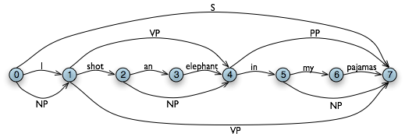

***Figure 4.5****: The Chart Data Structure: non-terminals are represented as extra edges in the chart.*

We conclude that there is a parse for the whole input string once we have constructed an S node in cell (0, 7), showing that we have found a sentence that covers the whole input. The final state of the WFST is depicted in [4.5](https://www.nltk.org/book/ch08.html#fig-chart-positions2).

Notice that we have not used any built-in parsing functions here. We've implemented a complete, primitive chart parser from the ground up!

WFST's have several shortcomings. First, as you can see, the WFST is not itself a parse tree, so the technique is strictly speaking **recognizing** that a sentence is admitted by a grammar, rather than parsing it. Second, it requires every non-lexical grammar production to be *binary*. Although it is possible to convert an arbitrary CFG into this form, we would prefer to use an approach without such a requirement. Third, as a bottom-up approach it is potentially wasteful, being able to propose constituents in locations that would not be licensed by the grammar.

Finally, the WFST did not represent the structural ambiguity in the sentence (i.e. the two verb phrase readings). The VP in cell (1, 7) was actually entered twice, once for a V NP reading, and once for a VP PP reading. These are different hypotheses, and the second overwrote the first (as it happens this didn't matter since the left hand side was the same.) Chart parsers use a slighly richer data structure and some interesting algorithms to solve these problems (see the Further Reading section at the end of this chapter for details).

**Note**

**Your Turn:** Try out the interactive chart parser application nltk.app.chartparser().

**5   Dependencies and Dependency Grammar**

Phrase structure grammar is concerned with how words and sequences of words *combine* to form constituents. A distinct and complementary approach, dependency grammar, focusses instead on how words *relate* to other words. Dependency is a binary asymmetric relation that holds between a **head** and its **dependents**. The head of a sentence is usually taken to be the tensed verb, and every other word is either dependent on the sentence head, or connects to it through a path of dependencies.

A dependency representation is a labeled directed graph, where the nodes are the lexical items and the labeled arcs represent dependency relations from heads to dependents. [5.1](https://www.nltk.org/book/ch08.html" \l "fig-depgraph0) illustrates a dependency graph, where arrows point from heads to their dependents.

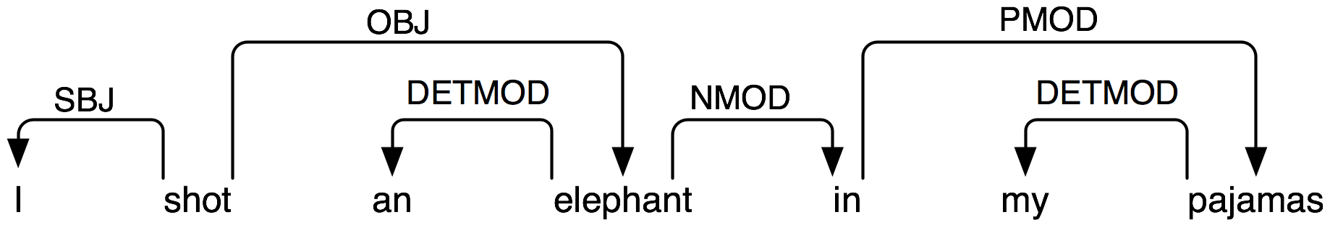

***Figure 5.1****: Dependency Structure: arrows point from heads to their dependents; labels indicate the grammatical function of the dependent as subject, object or modifier.*

The arcs in [5.1](https://www.nltk.org/book/ch08.html#fig-depgraph0) are labeled with the grammatical function that holds between a dependent and its head. For example, *I* is the SBJ (subject) of *shot* (which is the head of the whole sentence), and *in* is an NMOD (noun modifier of *elephant*). In contrast to phrase structure grammar, therefore, dependency grammars can be used to directly express grammatical functions as a type of dependency.

Here's one way of encoding a dependency grammar in NLTK — note that it only captures bare dependency information without specifying the type of dependency:

|  |  |  |
| --- | --- | --- |
| |  |  | | --- | --- | |  | **>>> groucho\_dep\_grammar = nltk.DependencyGrammar.fromstring("""**  **... 'shot' -> 'I' | 'elephant' | 'in'**  **... 'elephant' -> 'an' | 'in'**  **... 'in' -> 'pajamas'**  **... 'pajamas' -> 'my'**  **... """)**  **>>> print(groucho\_dep\_grammar)**  **Dependency grammar with 7 productions**  **'shot' -> 'I'**  **'shot' -> 'elephant'**  **'shot' -> 'in'**  **'elephant' -> 'an'**  **'elephant' -> 'in'**  **'in' -> 'pajamas'**  **'pajamas' -> 'my'** | |

A dependency graph is **projective** if, when all the words are written in linear order, the edges can be drawn above the words without crossing. This is equivalent to saying that a word and all its descendents (dependents and dependents of its dependents, etc.) form a contiguous sequence of words within the sentence. [5.1](https://www.nltk.org/book/ch08.html" \l "fig-depgraph0) is projective, and we can parse many sentences in English using a projective dependency parser. The next example shows how groucho\_dep\_grammar provides an alternative approach to capturing the attachment ambiguity that we examined earlier with phrase structure grammar.

|  |  |  |
| --- | --- | --- |
| |  |  | | --- | --- | |  | **>>> pdp = nltk.ProjectiveDependencyParser(groucho\_dep\_grammar)**  **>>> sent = 'I shot an elephant in my pajamas'.split()**  **>>> trees = pdp.parse(sent)**  **>>> for tree in trees:**  **... print(tree)**  **(shot I (elephant an (in (pajamas my))))**  **(shot I (elephant an) (in (pajamas my)))** | |

These bracketed dependency structures can also be displayed as trees, where dependents are shown as children of their heads.

|  |  |  |
| --- | --- | --- |
| (14) |  | tree_images/ch08-tree-10.pngtree_images/ch08-tree-11.png |

In languages with more flexible word order than English, non-projective dependencies are more frequent.

Various criteria have been proposed for deciding what is the head *H* and what is the dependent *D* in a construction *C*. Some of the most important are the following:

1. *H* determines the distribution class of *C*; or alternatively, the external syntactic properties of *C* are due to *H*.
2. *H* determines the semantic type of *C*.
3. *H* is obligatory while *D* may be optional.
4. *H* selects *D* and determines whether it is obligatory or optional.
5. The morphological form of *D* is determined by *H* (e.g. agreement or case government).

When we say in a phrase structure grammar that the immediate constituents of a PP are P and NP, we are implicitly appealing to the head / dependent distinction. A prepositional phrase is a phrase whose head is a preposition; moreover, the NP is a dependent of P. The same distinction carries over to the other types of phrase that we have discussed. The key point to note here is that although phrase structure grammars seem very different from dependency grammars, they implicitly embody a recognition of dependency relations. While CFGs are not intended to directly capture dependencies, more recent linguistic frameworks have increasingly adopted formalisms which combine aspects of both approaches.

**5.1   Valency and the Lexicon**

Let us take a closer look at verbs and their dependents. The grammar in [3.3](https://www.nltk.org/book/ch08.html#code-cfg2) correctly generates examples like [(15d)](https://www.nltk.org/book/ch08.html#ex-subcat1).

|  |  |  |  |  |  |  |  |  |  |  |  |  |  |  |
| --- | --- | --- | --- | --- | --- | --- | --- | --- | --- | --- | --- | --- | --- | --- |
| (15) |  | |  |  |  | | --- | --- | --- | | a. |  | The squirrel was frightened. |  |  |  |  | | --- | --- | --- | | b. |  | Chatterer saw the bear. |  |  |  |  | | --- | --- | --- | | c. |  | Chatterer thought Buster was angry. |  |  |  |  | | --- | --- | --- | | d. |  | Joe put the fish on the log. | |

These possibilities correspond to the following productions:

***Table 5.1****:*

VP productions and their lexical heads

|  |  |
| --- | --- |
| VP -> V Adj | *was* |
| VP -> V NP | *saw* |
| VP -> V S | *thought* |
| VP -> V NP PP | *put* |

That is, *was* can occur with a following Adj, *saw* can occur with a following NP, *thought* can occur with a following S and *put* can occur with a following NP and PP. The dependents Adj, NP, PP and S are often called **complements** of the respective verbs and there are strong constraints on what verbs can occur with what complements. By contrast with [(15d)](https://www.nltk.org/book/ch08.html" \l "ex-subcat1), the word sequences in [(16d)](https://www.nltk.org/book/ch08.html#ex-subcat2) are ill-formed:

|  |  |  |  |  |  |  |  |  |  |  |  |  |  |  |
| --- | --- | --- | --- | --- | --- | --- | --- | --- | --- | --- | --- | --- | --- | --- |
| (16) |  | |  |  |  | | --- | --- | --- | | a. |  | \*The squirrel was Buster was angry. |  |  |  |  | | --- | --- | --- | | b. |  | \*Chatterer saw frightened. |  |  |  |  | | --- | --- | --- | | c. |  | \*Chatterer thought the bear. |  |  |  |  | | --- | --- | --- | | d. |  | \*Joe put on the log. | |

**Note**

With a little imagination, it is possible to invent contexts in which unusual combinations of verbs and complements are interpretable. However, we assume that the above examples are to be interpreted in neutral contexts.

In the tradition of dependency grammar, the verbs in [5.1](https://www.nltk.org/book/ch08.html#tab-subcat) are said to have different **valencies**. Valency restrictions are not just applicable to verbs, but also to the other classes of heads.

Within frameworks based on phrase structure grammar, various techniques have been proposed for excluding the ungrammatical examples in [(16d)](https://www.nltk.org/book/ch08.html" \l "ex-subcat2). In a CFG, we need some way of constraining grammar productions which expand VP so that verbs *only* co-occur with their correct complements. We can do this by dividing the class of verbs into "subcategories", each of which is associated with a different set of complements. For example, **transitive verbs** such as *chased* and *saw* require a following NP object complement; that is, they are **subcategorized** for NP direct objects. If we introduce a new category label for transitive verbs, namely TV (for Transitive Verb), then we can use it in the following productions:

VP -> TV NP

TV -> 'chased' | 'saw'

Now *\*Joe thought the bear* is excluded since we haven't listed *thought* as a TV, but *Chatterer saw the bear* is still allowed. [5.2](https://www.nltk.org/book/ch08.html" \l "tab-verbcat) provides more examples of labels for verb subcategories.

***Table 5.2****:*

Verb Subcategories

| **Symbol** | **Meaning** | **Example** |
| --- | --- | --- |
| IV | intransitive verb | *barked* |
| TV | transitive verb | *saw a man* |
| DatV | dative verb | *gave a dog to a man* |
| SV | sentential verb | *said that a dog barked* |

Valency is a property of lexical items, and we will discuss it further in [9.](https://www.nltk.org/book/ch09.html#chap-featgram).

Complements are often contrasted with modifiers (or adjuncts), although both are kinds of dependent. Prepositional phrases, adjectives and adverbs typically function as modifiers. Unlike complements, modifiers are optional, can often be iterated, and are not selected for by heads in the same way as complements. For example, the adverb *really* can be added as a modifer to all the sentence in [(17d)](https://www.nltk.org/book/ch08.html#ex-mod):

|  |  |  |  |  |  |  |  |  |  |  |  |  |  |  |
| --- | --- | --- | --- | --- | --- | --- | --- | --- | --- | --- | --- | --- | --- | --- |
| (17) |  | |  |  |  | | --- | --- | --- | | a. |  | The squirrel really was frightened. |  |  |  |  | | --- | --- | --- | | b. |  | Chatterer really saw the bear. |  |  |  |  | | --- | --- | --- | | c. |  | Chatterer really thought Buster was angry. |  |  |  |  | | --- | --- | --- | | d. |  | Joe really put the fish on the log. | |

The structural ambiguity of PP attachment, which we have illustrated in both phrase structure and dependency grammars, corresponds semantically to an ambiguity in the scope of the modifier.

**5.2   Scaling Up**

So far, we have only considered "toy grammars," small grammars that illustrate the key aspects of parsing. But there is an obvious question as to whether the approach can be scaled up to cover large corpora of natural languages. How hard would it be to construct such a set of productions by hand? In general, the answer is: *very hard*. Even if we allow ourselves to use various formal devices that give much more succinct representations of grammar productions, it is still extremely difficult to keep control of the complex interactions between the many productions required to cover the major constructions of a language. In other words, it is hard to modularize grammars so that one portion can be developed independently of the other parts. This in turn means that it is difficult to distribute the task of grammar writing across a team of linguists. Another difficulty is that as the grammar expands to cover a wider and wider range of constructions, there is a corresponding increase in the number of analyses which are admitted for any one sentence. In other words, ambiguity increases with coverage.

Despite these problems, some large collaborative projects have achieved interesting and impressive results in developing rule-based grammars for several languages. Examples are the Lexical Functional Grammar (LFG) Pargram project, the Head-Driven Phrase Structure Grammar (HPSG) LinGO Matrix framework, and the Lexicalized Tree Adjoining Grammar XTAG Project.

**6   Grammar Development**

Parsing builds trees over sentences, according to a phrase structure grammar. Now, all the examples we gave above only involved toy grammars containing a handful of productions. What happens if we try to scale up this approach to deal with realistic corpora of language? In this section we will see how to access treebanks, and look at the challenge of developing broad-coverage grammars.

**6.1   Treebanks and Grammars**

The corpus module defines the treebank corpus reader, which contains a 10% sample of the Penn Treebank corpus.

|  |  |  |
| --- | --- | --- |
| |  |  | | --- | --- | |  | **>>> from nltk.corpus import treebank**  **>>> t = treebank.parsed\_sents('wsj\_0001.mrg')[0]**  **>>> print(t)**  **(S**  **(NP-SBJ**  **(NP (NNP Pierre) (NNP Vinken))**  **(, ,)**  **(ADJP (NP (CD 61) (NNS years)) (JJ old))**  **(, ,))**  **(VP**  **(MD will)**  **(VP**  **(VB join)**  **(NP (DT the) (NN board))**  **(PP-CLR**  **(IN as)**  **(NP (DT a) (JJ nonexecutive) (NN director)))**  **(NP-TMP (NNP Nov.) (CD 29))))**  **(. .))** | |

We can use this data to help develop a grammar. For example, the program in [6.1](https://www.nltk.org/book/ch08.html#code-sentential-complement) uses a simple filter to find verbs that take sentential complements. Assuming we already have a production of the form VP -> Vs S, this information enables us to identify particular verbs that would be included in the expansion of Vs.

|  |  |  |
| --- | --- | --- |
| |  |  | | --- | --- | |  | **def filter(tree):**  **child\_nodes = [child.label() for child in tree**  **if isinstance(child, nltk.Tree)]**  **return (tree.label() == 'VP') and ('S' in child\_nodes)** | |
| |  |  | | --- | --- | |  | **>>> from nltk.corpus import treebank**  **>>> [subtree for tree in treebank.parsed\_sents()**  **... for subtree in tree.subtrees(filter)]**  **[Tree('VP', [Tree('VBN', ['named']), Tree('S', [Tree('NP-SBJ', ...]), ...]), ...]** | |
| [**Example 6.1 (code\_sentential\_complement.py)**](https://www.nltk.org/book/pylisting/code_sentential_complement.py): **Figure 6.1**: Searching a Treebank to find Sentential Complements |

The Prepositional Phrase Attachment Corpus, nltk.corpus.ppattach is another source of information about the valency of particular verbs. Here we illustrate a technique for mining this corpus. It finds pairs of prepositional phrases where the preposition and noun are fixed, but where the choice of verb determines whether the prepositional phrase is attached to the VP or to the NP.

|  |  |  |
| --- | --- | --- |
| |  |  | | --- | --- | |  | **>>> from collections import defaultdict**  **>>> entries = nltk.corpus.ppattach.attachments('training')**  **>>> table = defaultdict(lambda: defaultdict(set))**  **>>> for entry in entries:**  **... key = entry.noun1 + '-' + entry.prep + '-' + entry.noun2**  **... table[key][entry.attachment].add(entry.verb)**  **...**  **>>> for key in sorted(table):**  **... if len(table[key]) > 1:**  **... print(key, 'N:', sorted(table[key]['N']), 'V:', sorted(table[key]['V']))** | |

Amongst the output lines of this program we find offer-from-group N: ['rejected'] V: ['received'], which indicates that *received* expects a separate PP complement attached to the VP, while *rejected* does not. As before, we can use this information to help construct the grammar.

The NLTK corpus collection includes data from the PE08 Cross-Framework and Cross Domain Parser Evaluation Shared Task. A collection of larger grammars has been prepared for the purpose of comparing different parsers, which can be obtained by downloading the large\_grammars package (e.g. python -m nltk.downloader large\_grammars).

The NLTK corpus collection also includes a sample from the *Sinica Treebank Corpus*, consisting of 10,000 parsed sentences drawn from the *Academia Sinica Balanced Corpus of Modern Chinese*. Let's load and display one of the trees in this corpus.

|  |  |  |
| --- | --- | --- |
| |  |  | | --- | --- | |  | **>>> nltk.corpus.sinica\_treebank.parsed\_sents()[3450].draw()** | |

